ProgramAB4

use science;
show databases;
create table DBMT(
student_id int auto_increment,
name varchar(100),
primary key(student_id)
);
desc DBMT;

create table entrollments9(
entrollment_id int auto_increment,
student_id int,
corse_name varchar(100),
primary key(entrollment_id),
foreign key (student_id)references DBMT(student_id)
);
desc entrollments9;
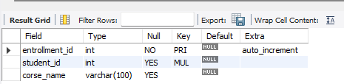
insert into DBMT(name)
values('Aish'),
('Sumit'),
('Shreya'),
('Tina');
select*from DBMT;
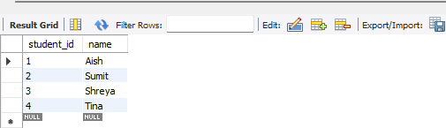
insert into entrollments9(student_id,corse_name)
values(1,'CS'),
(2,'ST'),
(3,'DSOOP'),
(4,'CSO');
select*from entrollments9;
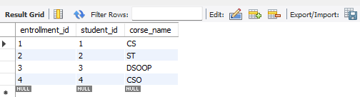

select
s.name,
e.corse_name
from
DBMT s
join
entrollments9 e on s.student_id=e.student_id;


